
Artificial intelligence
(LAB)


Submitted By:
Name: Maira
Roll No: 249
Section: BSAI-3D

Submitted To:
Sir Rasikh

Lab 5: Adversarial Search — Minimax & Alpha-Beta Pruning

Introduction
In this lab, I learned how an AI agent makes decisions in a two-player game. Minimax helps the agent choose the best move by assuming that both players will play intelligently. Alpha-Beta Pruning improves this process by skipping branches that cannot affect the final decision.

Objective
- Understand MAX and MIN players in a game tree.
- Calculate the Minimax value from leaf nodes to the root.
- Apply Alpha-Beta Pruning to reduce unnecessary calculations.
- Compare the number of evaluated leaves in both algorithms.

Task 1: Trace the Supplied Tree by Hand Using Minimax
Given Leaf Values
The leaf values used in this task are:
[3, 5, 2, 9, 3, 5, 2, 9]
The tree has three levels of decisions:
- Root node: MAX
- Second level: MIN
- Third level: MAX
- Final level: Leaf values
Minimax Calculation
Step 1: MAX level
MAX selects the larger value from each pair:
- MAX(3, 5) = 5
- MAX(2, 9) = 9
- MAX(3, 5) = 5
- MAX(2, 9) = 9
Step 2: MIN level
MIN selects the smaller value from each pair:
- MIN(5, 9) = 5
- MIN(5, 9) = 5
Step 3: Root MAX level
The root selects the maximum value:
- MAX(5, 5) = 5
Final Result
The optimal Minimax value is 5.
This means the MAX player can guarantee an outcome of 5 if both players make their best decisions.

Output:

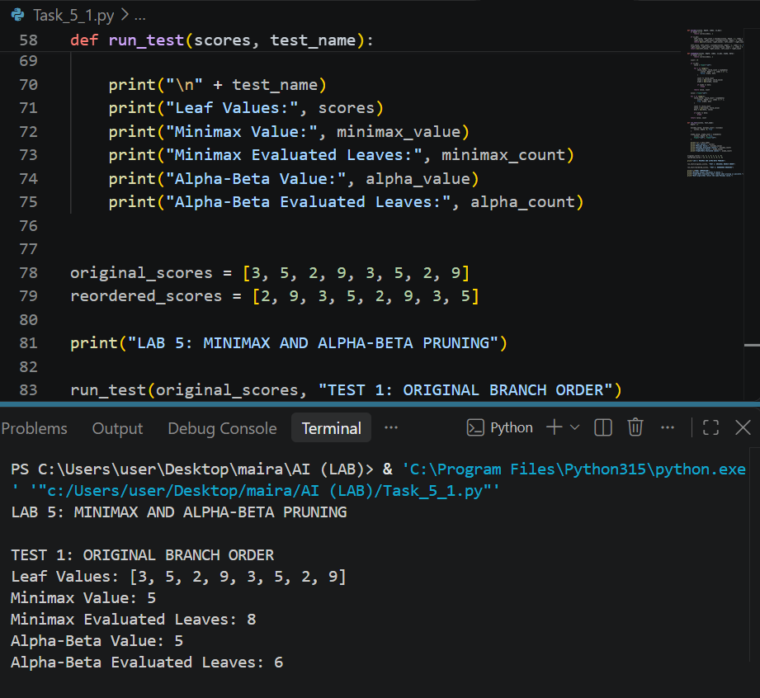
=================================================================

Task 2: Add a Leaf-Evaluation Counter to Both Algorithms
A leaf-evaluation counter keeps track of how many terminal nodes an algorithm checks before making its decision.
Minimax
Minimax checks every leaf in the tree because it does not skip any branch.
- Total leaf nodes: 8
- Evaluated leaves: 8
- Root value: 5
Alpha-Beta Pruning
Alpha-Beta Pruning uses two values:
- Alpha: The best value MAX can guarantee so far.
- Beta: The best value MIN can guarantee so far.
When alpha becomes greater than or equal to beta, the remaining branches can be skipped.
Using the same tree and left-to-right branch order:
- First MIN branch returns 5.
- MAX updates alpha to 5.
- In the second MIN branch, the first MAX child returns 5.
- Beta becomes 5, so alpha is equal to beta.
- The remaining branch is pruned.
Results Comparison
Algorithm | Root Value | Evaluated Leaves
Minimax | 5 | 8
Alpha-Beta | 5 | 6
Interpretation
Both algorithms return the same optimal value of 5. However, Alpha-Beta Pruning evaluates only 6 leaves instead of 8. This shows that pruning reduces unnecessary search while preserving the Minimax result.

Output:

====================================================================

Task 3: Reorder Branches and Observe Pruning
In this task, the order of branches is changed to observe how it affects Alpha-Beta Pruning.
Original Order
[3, 5, 2, 9, 3, 5, 2, 9]
- Minimax value: 5
- Alpha-Beta evaluated leaves: 6
Reordered Values
[2, 9, 3, 5, 2, 9, 3, 5]
The values inside each pair and their positions in the game tree are changed by reordering the branches.
The Minimax result remains 5 because the same terminal values are used and the tree structure is unchanged.
With this ordering, Alpha-Beta can evaluate more leaves before finding a useful cutoff.
Comparison
Test | Minimax Value | Minimax Leaves | Alpha-Beta Leaves
Original Order | 5 | 8 | 6
Reordered Branches | 5 | 8 | 8
Interpretation
Changing the branch order can affect how many leaves Alpha-Beta Pruning evaluates. A good move order can help the algorithm prune more branches. However, the final Minimax value remains the same.
Edge Case and Comparison
An important edge case occurs when Alpha is equal to Beta. In this situation, the remaining branch can be skipped because it cannot improve the final decision.
Another important case is when no branch can be pruned. Alpha-Beta may then evaluate all leaves, just like ordinary Minimax.
This shows that pruning depends on the values and the order in which branches are checked.

Limitations
- Minimax can become slow when the game tree is very large.
- Alpha-Beta Pruning depends on branch ordering.
- Poor ordering may reduce the benefit of pruning.
- Both algorithms require a clear game tree and terminal values.

Reflection
1. What did you learn today?
I learned how Minimax selects the best move and how Alpha-Beta Pruning skips unnecessary branches.
2. How will you apply this in a real AI system?
These algorithms can be used in game-playing AI systems such as chess and other two-player games.
3. What failed or surprised you?
I found it interesting that Alpha-Beta can reduce calculations without changing the final decision.
4. What would you do differently next time?
I would try different branch orders to understand how they affect pruning.

Responsible Practice
The game tree, leaf values and pruning decisions should be clearly shown so that the results can be checked and reproduced. The algorithm should be tested with different inputs instead of relying on only one example.

Conclusion
In this lab, I implemented and compared Minimax and Alpha-Beta Pruning. Both algorithms produced the same optimal value, but Alpha-Beta Pruning reduced the number of evaluated leaves in the original branch order. This helped me understand how pruning makes game-tree searching more efficient.
References
- Artificial Intelligence Lab Manual, Lab 5: Adversarial Search — Minimax & Alpha-Beta Pruning.
- Python Official Documentation.

Output:



